** TECHNICAL SEMINAR**

**ON**

**“ARTIFICIAL INTELLIGENCE IN POWER SYSTEMS”**

**A technical seminar report submitted for partial fulfillment of the requirements for the award of B.Tech Degree in**

**Electronics and Telecommunication Engineering under BPUT**

**SUBMITTED BY:**

**Name-CHANDAN KUMAR SAHOO**

**Registration No-1601289446**

**Sec-ETC-B**

**DEPARTMENT OF ELECTRONICS AND TELECOMMUNICATION ENGINEERING**

**TRIDENT ACADEMY OF TECHNOLOGY**

**BHUBANESWAR**



**TRIDENT ACADEMY OF TECHNOLOGY**

**BHUBANESWAR**

**CERTIFICATE**

This is to certify that CHANDAN KUMAR SAHOO, bearing Regd.No.1601289446, student of seventh semester, Electronics and Telecommunication Engineering, Trident Academy of Technology, Bhubaneswar has submitted seminar report on “**ARTIFICIAL INTELLIGENCE IN POWER SYSTEMS** ”.

This is required for the partial fulfilment for Bachelor’s Degree in Electronics & Telecommunication Engineering under BPUT.

**SEMINAR COORDINATOR HEAD OF THE DEPT.**

I would like to extend my sincere thanks to Prof. (Dr.) Sakuntala Mahapatra, HOD, Department of Electronics and Telecommunication Engineering, for providing the necessary facilities. I wish to express my thankfulness to the seminar coordinators, for helping me to complete the seminar successfully. I would also like to convey my gratefulness to my guide whose co-operative guidance has helped me in the successful completion of this seminar.

I take this opportunity to express my heartfelt thanks to all those who individually as well as collectively helped me in the successful completion of this seminar.

I wish to extend my deep sense of gratitude and appreciation to all the faculty members of the Dept. of Electronics & Telecommunication Engineering for their valuable and scholarly guidance, constant supervision and timely advice, also to the non-teaching staff of the Dept. of Electronics & Telecommunication and my friends without whom my endeavours wouldn’t have been successful.

**Name-CHANDAN KUMAR SAHOO**

**Regd.no-1601289446**

**ABSTRACT**

The purpose of this paper is to research on artificial intelligence in power system operation and on transient protection, through the use of discrete control and the continuous control to increase the stability of the power system; transient protection is through the use of relay protection based on expert system and fuzzy logic in the protection setting calculation of expert and fault diagnosis, greatly improved the efficiency of solving the problem. This paper originally were studied in artificial intelligence in power system on steady and transient, introducing the most suitable method, which can be used as reference in practical application. All in all artificial intelligence is the ability using computers to perform some complex problems to solve, such as image recognition, judge the ability to understand the problem.Recently, due to concerns about the liberalization of electricity supply, deregulation, and global impact on the environment, securing a reliable power supply has become an important social need worldwide. To ensure this need is fulfilled, detailed investigations and developments are in progress on power distribution systems and the monitoring of apparatus. Intelligent system techniques may be of great help in the implementation of area power system controls. Most of these applications require large quantities of system information, which can be provided by modern telecommunications and computing technology, but require new processing techniques able to extract salient information from these large sets of raw data. Importantly, such large data sets are never error free and often contain various types of uncertainty. Finally, control actions may be based on operating strategies specified in qualitative form, which need to be translated into quantitative decisions. A continuous and reliable supply of electricity is necessary for the functioning of today’s modern and advanced society. Since the early to mid 1980s, most of the effort in power systems analysis has turned away from the methodology of formal mathematical modeling which came from the areas of operations research, control theory and numerical analysis to the less rigorous and less tedious techniques of artificial intelligence (AI). Power systems keep on increasing on the basis of geographical regions, assets additions, and introduction of new technologies in generation, transmission and distribution of electricity. AI techniques have become popular for solving different problems in power systems like control, planning, scheduling, forecast, etc. These techniques can deal with difficult tasks faced by applications in modern large power systems with even more interconnections installed to meet increasing load demand. The application of these techniques has been successful in many areas of power system engineering.

**Name-CHANDAN KUMAR SAHOO**

**Regd.no-1601289446**

**CONTENTS**

**TOPICS PAGE NO.**

1. **Introduction** 01
2. **Artificial Intelligence Techniques 02**
3. **Application of Artificial Intelligence** 03-04
4. **Power Systems** 05-

**a) Thermal power plants -**

**b) Hydal power plants -**

**c) Nuclear power plants 07**

1. **Need for AI in Power system 08**
2. **Artificial Intelligence Techniques 09**
3. **Artificial nural network (ANN) 10**
4. **Fuzzy Logic 11-12**
5. **Expert system 13-14**
6. **CURRENT APPLICATION OF AI IN POWER SYSTEMS 15**
7. **Applications 16-19**

.

.

.

.

.

.

.

.

.

.

1. **Conclusion** 20
2. **References** 21

**INTRODUCTION**

**Artificial intelligence** is a scientific discipline aiming to research, develop and simulate of human behavior and its rules. Artificial intelligence techniques including Brain Science, Neurology, information technology and various discipline artificial intelligence techniques including Brain Science, Neurology, and disciplines such as information technology, widely used in all walks of life, through to mimic the behaviorof the human brain, developed a way to replace human brains discover, identify and analyze machine, improve efficiency and save money.

Traditional artificial intelligence includes problem solving and in the process of development to improve the AI induction and basic search technology; meanwhile, in logical reasoning and theorem proving, automatic programming, natural language understanding, expert system all get great achievements. But as for improving own learning and performance aspects have no substantive progress. Limitations of traditional artificial intelligence can only simulate one logical thinking to solve the problem, and cannot be solved in addition to logical thinking, dynamic thinking and some problems that cannot be represented into the sequence of symbols. But in recent years, another kind of intelligent way that artificial neural networks develop fast and can be combined with the traditional AI, to make up for the shortcoming of traditional AI.

**Modern artificial intelligence technologies include:**

(1) The artificial neural network The artificial neural network(ANN) Artificial neural network (ANN) is from the perspective of simulated neurons process information using nonlinear mapping method of brain information processing, storage and search mechanism and combining it with AI mechanism. Through connections in a number of simple elements and samples to learn, constantly adjusting weight finally getting the right results and resolve the complex equations and nonlinear problems brought by the difficulties. And ANN massively parallel processing capabilities, and ANN's large scale parallel processing ability, adaptive learning ability, using information distributed storage capacity and robustness of fault tolerance and generalization ability in fault diagnosis have important application.

(2) The theory of fuzzy recognition and diagnosis Fuzzy theory by definition is fuzzy concepts and mathematical models for handling the practical concept is not clear or obscure facts such as: excessive current, too much loss in which membership does not clear. Fuzzy identification on uncertain events and phenomena are screened to establish mathematical model and input variables. The problem and efficiency of fault diagnosis in power system are solved and improved

**APPLICATIONS AND PROTECTIONS OF ARTIFICIAL INTELLIGENCE SYSTEM**

Artificial intelligence power system is developing rapidly at present, artificial intelligence includes expert system, artificial neural network, fuzzy diagnosis theory and genetic algorithm. Each has its advantages and limitations, and the lack of a universal and effective method applied to all fields of power system. Hybrid intelligence, that is, a variety of intelligent technology, becoming one of the important development direction of AI . Distributed artificial intelligence is a branch of artificial intelligence research, in which parallel distributed computing eventually come into being. Now the structure of the neural network itself and the improvement of the algorithm is also an important task of AI exploration. More classic round cell neural network BP network with bounded generalization and refuse good characteristics.

With the rapid development of China's power grid scale and the construction of the special high-voltage power grid in North China, central China and East china. The need to consider the factors that affect the safe and stable operation of power grid more and more, the grid running mechanisms are more complex. In order to study the power system for the use of artificial intelligence tools to solve the problem of the characteristics divided problem on time frame into real-time control, management planning two parts .

**The Application of Artificial Intelligence in the System Operation Control**

Distribution of electric power system automation and manual control devices such as circuit breakers, relays, disconnecting switch and so on. These relatively simple local individuals element control complex and together constitute a whole power system real-time control that is discrete control and continuous control. Discrete control

(1) Cut load Load shedding is another kind of discrete control. When the system is disturbed or the generator is shut down, the capacity of the system is changed dramatically, while the load is kept at a high level, which is far beyond the system's supply, not to cause blackouts must reduce the load. Described by a differential problem of load demand and analysis of system behavior to control the relay action in a timely manner, you can use the function map to reflect. Artificial neural networks has the approximation of function mapping functions and parallel processing capabilities, it has a good adaptability to deal with load control and real-time, select an appropriate character input describing function mapping of key issues.

(2) Power system relay protection Relay protection is a kind of common discrete control, which is to detect and judge the normal or fault state in the system and can quickly react to the protection action. The ability to respond quickly and deal with the problem of AI has become an important tool for online assessment. Fuzzy identification theory contains a large area in the design of relay protection .Due to the adaptive ability of traditional protection, reaction ability of detection ability is limited, real-time tracking using the computer, the calculation characteristics of the running mode of protection device, making fuzzy in artificial intelligent control theory for the improvement of the computer provides an important method and way to realize the relay protection device. • Continuous control Excitation control is an important part of controlling the voltage and reactive power of the generator. It can maintain the stability of the power system in the disturbance environment. It is an important real time continuous control system against disturbance. But due to the application of large capacity unit input and fast excitation system, the dynamic stability of the system is coming into being, decreased ability of antiinterference, so the fuzzy set theory in the excitation control system greatly increases the excitation control system control rate and increases the stability of the power system.

**Application of Artificial Intelligence in Transient Protection**

* Concept of transient protection

Transient protection through detection of transient high frequency model for power system transmission line and power system to realize its own functions, the fault transient models include a lot of fault type, position, direction, duration, and so on. First of all, we must use the specific high-frequency detection device and algorithm to extract the high frequency signal from the fault model then use the special fast signal processing algorithm to determine what kind of fault. The principle block diagram of transmission line transient protection is shown in Figure 1.

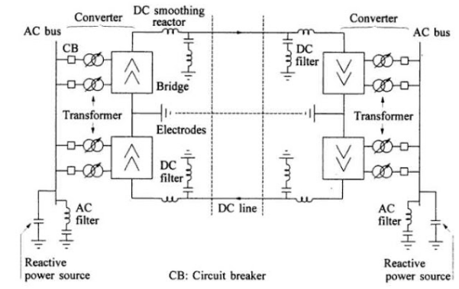

**FIGURE I. THE PRINCIPLE BLOCK DIAGRAM OF TRANSMISSION LINE TRANSIENT PROTECTION**

In Figure I, the transient protection including high frequency detection, fault identification, transient protection and transient adaptive reclosing these parts, switching in power system fault, lighten can generate high frequency signal, and transmission in the power system, a high frequency detector in the outlet line can detect the identification of non-fault disturbance.

When fault happening through fault protection, non-communication protection, transient protection principle to determine whether protection for area fault, if is ,tripping and then enter Adaptive reclosing unit, after tripping in high frequency signal analysis to identify whether the fault is a permanent fault, if it is not to close. Application of artificial intelligence in transient protection The application of artificial intelligence mainly includes the application of expert system, the application of artificial neural network, fuzzy set theory and genetic algorithm. But in the study of transient protection, it is used in the following two ways: the protection of expert system and fuzzy logic protection.

1. Based on theexpert system (system Expert) relay protection. The expert system has been applied in the power system for many years, but because of the protection of power system has strict requirements on reaction time, so the existing expert system is applied to the time required for protection is not very strict, such as: the choice of protection setting, fault diagnosis and fault location . This paper introduces the expert system used in relay protection setting calculation, through the general rules, comprehensive, comprehensive consideration of relay protection system setting involves the problem, to solve the contradictions of setting conflict.
2. Fuzzy logic protection. The variation of power system load is varied, such as the change of load, the diversification of power system network structure such as high voltage direct transmission, flexible transmission and series capacitor compensation. The relationship between the structure and components of these systems are very complex, which increases the difficulty of protecting, when disturbance occurs because of the above factors, there are too many uncertainties, not well defined and determined, so the input and output in the protection phase and the intermediate model system has fuzziness. It is precisely just because this fuzziness is more close to the actual characteristics, all of the conditions are given to consider more close to the practical application of [6] In this paper, fuzzy method is used to diagnose transformer fault, and the high frequency signal generated by partial discharge and the change of chemical composition in transformer are established. The fuzzy set is established, and the protection of transformer is achieved. But it is difficult to model the fuzzy technology, so it is often combined with neural network, and the neural network is composed of a large number of individual neurons in a certain way.

**POWER SYSTEMS:**

An electric power system is a network of electrical components used to supply, transmit and use electric power. Power systems engineering is a subdivision of electrical engineering that deals with the generation, transmission, distribution and utilisation of electric power and the electrical devices connected to such systems like generators, motors and transformers.

There are three types of major power plants known for the massive electricity generation:

**1) Thermal power plants**

**2) Hydal power plants**

**3) Nuclear power plants**

1. **Thermal Power Plant:**

A thermal power station is a power plant in which heat energy is converted to electric power. In most of the world the prime movers is steam driven. Water is heated, turns into steam and spins a steam turbine which drives an electrical generator. After it passes through the turbine, the steam is condensed in a condenser and recycled to where it was heated; this is known as a Rankine cycle. The greatest variation in the design of thermal power stations is due to the different heat sources, fossil fuel dominates here, although nuclear heat energy and solar heat energy are also used. In a thermal power station fuel such as coal, oil or gas is burned in a furnace to produce heat - chemical to heat energy. This heat is used to change water into steam in the boiler. this drives the generator to produce electricity .

.i.e,kinetic to electrical energy.

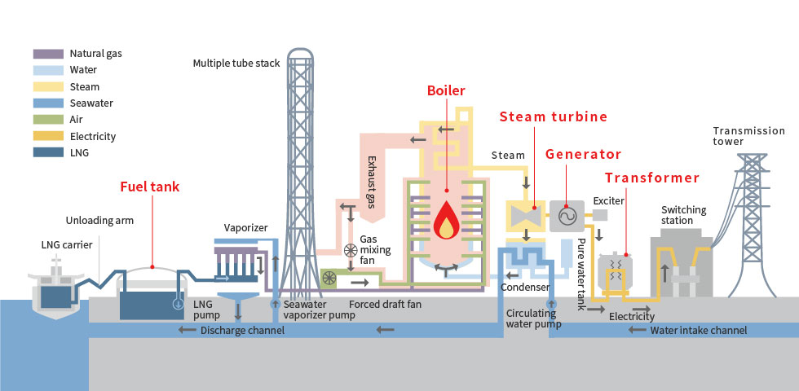

Fig1: Thermal Power plant

**B. Nuclear Power Plant:**

Nuclear plants, like plants that burn coal, oil and natural gas, produce electricity by boiling water into steam. This steam then turns turbines to produce electricity. The difference is that nuclear plants do not burn anything. Instead, they use uranium fuel, consisting of solid ceramic pellets, to produce electricity through a process called fission. Nuclear power plants obtain the heat needed to produce steam through a physical process. This process, called fission, entails the splitting of atoms of uranium in a nuclear reactor. The uranium fuel consists of small, hard ceramic pellets that are packaged into long, vertical tubes. Bundles of this fuel are inserted into the reactor. Commercial nuclear power plants in the are either boiling water reactors or pressurized water reactors. Approximately two-thirds of the reactors in the are pressurized water reactors, and one-third of them are boiling water reactors.

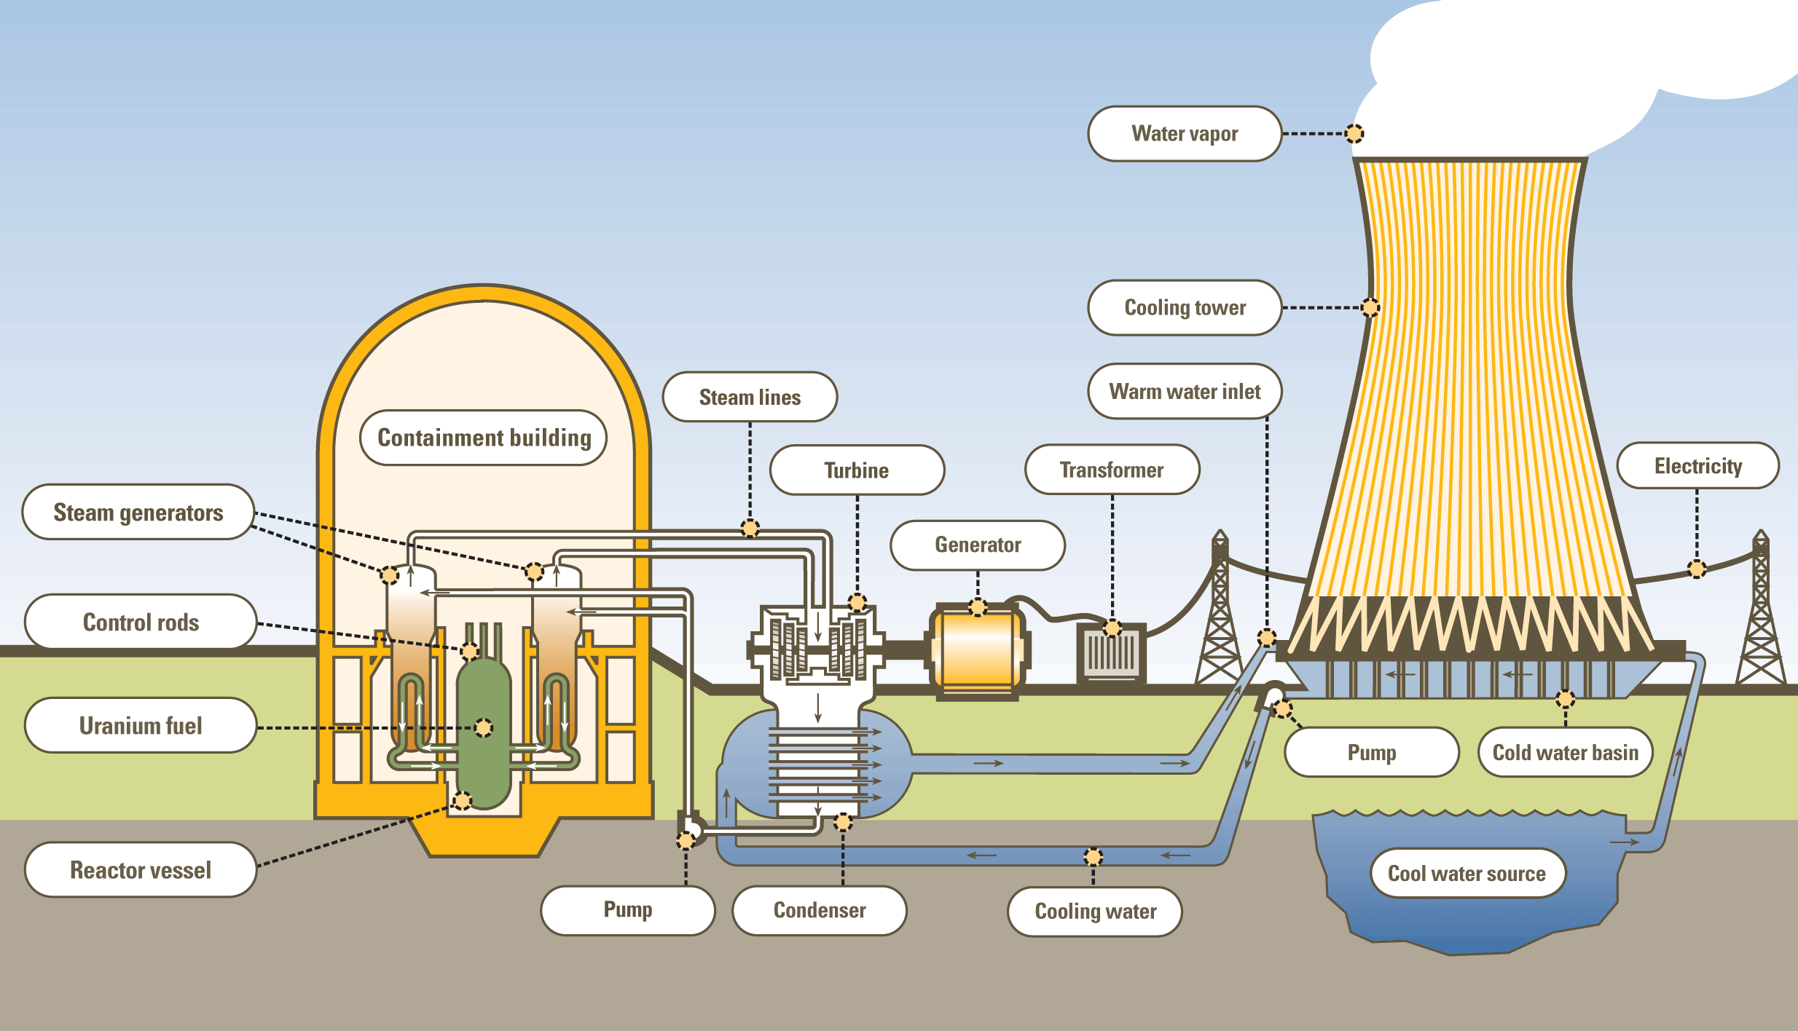

Fig 2: Nuclear Power Plant Structure

**Nuclear power plants** are a type of power plant that use the process of nuclear fission in order to generate electricity. They do this by using nuclear reactors in combination with the Rankine cycle, where the heat generated by the reactor converts water into steam, which spins a turbine and a generator. Nuclear power provides the world with around 11% of its total electricity, with the largest producers being the United States and France.

Aside from the source of heat, nuclear power plants are very similar to coal-fired power plants. However, they require different safety measures since the use of nuclear fuel has vastly different properties from coal or other fossil fuels.

1. **Hydro Power Plant:**

In Hydro Power Plant we use gravitational force of fluid water to run the turbine which is coupled with electric generator to produce electricity. This power plant plays an important role in protecting our fossil fuel which is limited, because the electricity generated is due to the use of water which is a renewable source of energy .The force of the water being released from the reservoir through the dam spins the blades of a giant turbine. The turbine is connected to the generator that makes electricity as it spins. After passing through the turbine, the water flows back into the river on the other side of the dam.

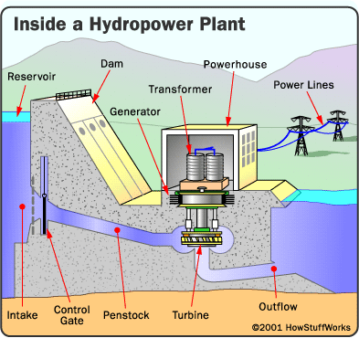

Fig 3: Hydro Power Plant Structure

Energy from the sun evaporates water in the Earth’s oceans and rivers and draws it upward as water vapor. When the water vapor reaches the cooler air in the atmosphere, it condenses and forms clouds. The moisture eventually falls to the Earth as rain or snow, replenishing the water in the oceans and rivers. Gravity drives the moving water, transporting it from high ground to low ground.

The force of moving water can be extremely powerful. Hydropower is called a renewable energy source because the water on Earth is continuously replenished by precipitation. As long as the water cycle continues, we won’t run out of this energy source. Hydroelectric power plants are different.

They use modern turbine generators to produce electricity, just as thermal (coal, natural gas, nuclear) power plants do, except they do not produce heat to spin the turbines. A dam serves two purposes at a hydropower plant. First, a dam increases the head, or height, of the water. Second, it controls the flow of water. Dams release water when it is needed for electricity production. Special gates called spillway gates release excess water from the reservoir during heavy rain falls.

**Need for AI in Power system:-**

Power system analysis by conventional techniques becomes more difficult because of: (i) Complex, versatile and large amount of information which is used in calculation, diagnosis and learning. (ii) Increase in the computational time period and accuracy due to extensive and vast system data handling.

The modern power system operates close to the limits due to the ever increasing energy consumption and the extension of currently existing electrical transmission networks and lines. This situation requires a less conservative power system operation and control operation which is possible only by continuously checking the system states in a much more detail manner than it was necessary. Sophisticated computer tools are now the primary tools in solving the difficult problems that arise in the areas of power system planning, operation, diagnosis and design. Among these computer tools, Artificial Intelligence has grown predominantly in recent years and has been applied to various areas of power systems.

Power system analysis by conventional techniques becomes more difficult because of:

(a) Complex, versatile and large amount of information which is used in calculation, diagnosis and learning.

(b) Increase in the computational time period and accuracy due to extensive and vast system data handling.

Artificial intelligence power system is developing rapidly at present, artificial intelligence includes expert system, artificial neural network, fuzzy diagnosis theory and genetic algorithm. Each has its advantages and limitations, and the lack of a universal and effective method applied to all fields of power system. Hybrid intelligence, that is, a variety of intelligent technology, becoming one of the important development direction of AI.

Distributed artificial intelligence is a branch of artificial intelligence research, in which parallel distributed computing eventually come into being. Now the structure of the neural network itself and the improvement of the algorithm is also an important task of AI exploration. More classic round cell neural network BP network with bounded generalization and refuse good characteristics.

Commonly, artificial intelligence is known to be the intelligence exhibited by machines and software, for example, robots and computer programs. The term is generally used for developing systems equipped with the intellectual features and characteristics of humans, like the ability to think, reason, generalize, distinguish, learn from past experience or rectify their mistakes. It generally refers to machines or programs with ability to think on an independent level from their operator to make decisions.

**ARTIFICIAL INTELLIGENCE TECHNIQUES:-**

Three major families of AI techniques are considered to be applied in modern power system protection

* **Artificial Neural Networks (ANNs),**
* **Fuzzy logic systems (FL).**
* **Expert System Techniques (XPSs),**

1. **Artificial Neural Networks:**

Artificial Neural Networks are systems designed based on organic thought processes which convert a set of inputs into a set of outputs by a network of neurons. Each neuron produces one output as a function of inputs. These system are used in real world applications wherein the need for classification of patterns and pattern recognition arises.

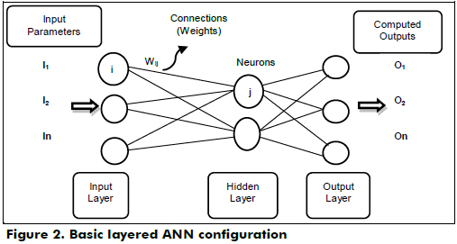

Fig 4 : Structure of an ANN

They are classified by their architecture: number of layers and topology: connectivity pattern, feed forward or recurrent.

Input Layer: The nodes are input units which do not process the data and information but distribute this data and information to other units. Hidden Layers: The nodes are hidden units that are not directly evident and visible. They provide the networks the ability to map or classify the nonlinear problems . Output Layer: The nodes are output units, which encode possible values to be allocated to the case under consideration.

Artificial neural networks are one of the main tools used in machine learning. As the “neural” part of their name suggests, they are brain-inspired systems which are intended to replicate the way that we humans learn. Neural networks consist of input and output layers, as well as (in most cases) a hidden layer consisting of units that transform the input into something that the output layer can use. They are excellent tools for finding patterns which are far too complex or numerous for a human programmer to extract and teach the machine to recognize.

**Application in Power Systems:**

As they are designed to perform biological based evaluvation of problems due to their inherent design, They are suitable for obtaining solutions to problems arising in power generation, distribution and transmission. Based on the constraints of a practical transmission system , taking into account factors such as environmental factors and other unbalancing features, ANN’s can arrive at a solution

Disadvantages:

(i) Large dimensionality.

(ii) Results are always generated even if the input data are unreasonable.

(iii) They are not scalable

i.e. once an ANN is trained to do certain task, it is difficult to extend for other tasks without retraining the neural network.

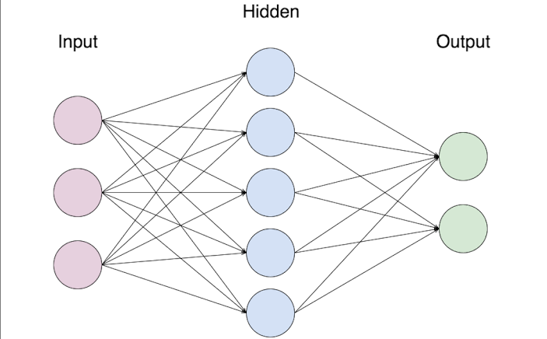

**Advantages of ANN**

* Speed of processing.
* They do not need any appropriate knowledge of the system model.
* They have ability to handle situation of incomplete data and information corrupt data.
* **Storing information on the entire network** : Information such as in **traditional programming** is stored on the entire network, not on a database. The disappearance of a few pieces of information in one place does not prevent the network from functioning.
* **Ability to work with** incomplete knowledge **:** After ANN training, the data may produce output even with incomplete information. The loss of performance here depends on the importance of the missing information.
* **Having fault tolerance:** Corruption of one or more cells of ANN does not prevent it from generating output. This feature makes the networks fault tolerant.
* **Having a distributed memory:**In order for ANN to be able to learn, it is necessary to determine the examples and to teach the network according to the desired output by showing these examples to the network. The network's success is directly proportional to the selected instances, and if the event can not be shown to the network in all its aspects, the network can produce false output

**B.FUZZY LOGIC:**

Fuzzy logic or Fuzzy systems are logical systems for standardisation and formalisation of approximate reasoning. It is similar to human decision making with an ability to produce exact and accurate solutions from certain or even approximate information and data. The reasoning in fuzzy logic is similar to human reasoning. Fuzzy logic is the way like which human brain works, and we can use this technology in machines so that they can perform somewhat like humans. Fuzzification provides superior expressive power, higher generality and an improved capability to model complex problems at low or moderate solution cost.

Fuzzy logic allows a particular level of ambiguity throughout an analysis. Because this ambiguity can specify available information and minimise problem complexity, fuzzy logic is useful in many applications. For power systems, fuzzy logic is suitable for applications in many areas where the available information involves uncertainty. For example, a problem might involve logical reasoning, but can be applied to numerical, other than symbolic inputs and outputs. Fuzzy logic provide the conversions from numerical to symbolic inputs, and back again for the outputs .

Fuzzy Logic Controller: Simply put, it is a fuzzy code designed to control something, generally mechanical input. They can be in software or hardware mode and can be used in anything from small circuits to large mainframes. Adaptive fuzzy controllers learn to control complex process much similar to as we do.

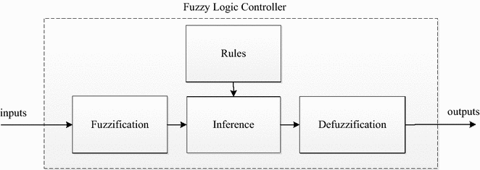

Fig 5: Fuzzy Logic Controller

**Applications:**

(i) Stability analysis and enhancement

(ii) Power system control

(iii) Fault diagnosis

(iv) Security assessment

(v) Load forecasting

(vi) Reactive power planning and its control

(vii) State estimation

Application in Power Systems: Fuzzy logic can be used for designing the physical components of power systems. They can be used in anything from small circuits to large mainframes. They can be used to increase the efficiency of the components used in power systems. As most of the data used in power system analysis are approximate values and assumptions, fuzzy logic can be of great use to derive a stable, exact and ambiguity-free output.

## Application Areas of Fuzzy Logic

The key application areas of fuzzy logic are as given −

**Automotive Systems**

* Automatic Gearboxes
* Four-Wheel Steering
* Vehicle environment control

**Consumer Electronic Goods**

* Hi-Fi Systems
* Photocopiers
* Still and Video Cameras
* Television

1. **EXPERT SYSTEMS:**

An expert system obtains the knowledge of a human expert in a narrow specified domain into a machine implementable form. Expert systems are computer programs which have proficiency and competence in a particular field. This knowledge is generally stored separately from the program’s procedural part and may be stored in one of the many forms, like rules, decision trees, models, and frames. They are also called as knowledge based systems or rule based systems. Expert systems use the interface mechanism and knowledge to solve problems which cannot be or difficult to be solved by human skill and intellect.

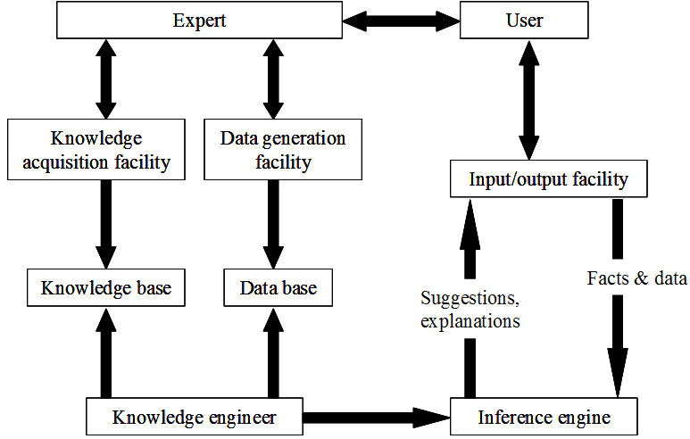

Fig 6: Structure of expert system

## Expert Systems Limitations

No technology can offer easy and complete solution. Large systems are costly, require significant development time, and computer resources. ESs have their limitations which include −

* Limitations of the technology
* Difficult knowledge acquisition
* ES are difficult to maintain
* High development costs

## Capabilities of Expert Systems

The expert systems are capable of −

* Advising
* Instructing and assisting human in decision making
* Demonstrating
* Deriving a solution
* Diagnosing
* Explaining
* Interpreting input
* Predicting results
* Justifying the conclusion
* Suggesting alternative options to a problem

They are incapable of −

* Substituting human decision makers
* Possessing human capabilities
* Producing accurate output for inadequate knowledge base
* Refining their own knowledge

**Advantages:**

1. It is permanent and consistent.
2. It can be easily documented.
3. It can be easily transferred or reproduced.

**Disadvantage:**

Expert Systems are unable to learn or adapt to new problems or situations.

**Applications:**

Many areas of applications in power systems match the abilities of expert systems like decision making, archiving knowledge, and solving problems by reasoning, heuristics and judgment. Expert systems are especially useful for these problems when a large amount of data and information must be processed in a short period of time.

How expert systems can be used in power systems: Since expert systems are basically computer programs, the process of writing codes for these programs is simpler than actually calculating and estimating the value of parameters used in generation, transmission and distribution. Any modifications even after design can be easily done because they are computer programs. Virtually, estimation of these values can be done and further research for increasing the efficiency of the process can be also performed density B or magnetic field strength symbolized as µ0H. Use the center dot to separate compound units.

**CURRENT APPLICATION OF AI IN POWER SYSTEMS :**

Several problems in power systems cannot be solved by conventional techniques are based on several requirements which may not feasible all the time. In these situations, artificial intelligence techniques are the obvious and the only option. Areas of application of AI in power systems are:

* Replacing human workers for dangerous and highly specialized operations, such as live maintenance of high voltage transmission lines, has been a long standing effect in the power community.
* Operation in hazardous environments, such as radioactive locations in nuclear plants, access to tight spaces, such as cable viaducts and cooling pipes, and precise positioning of measurement equipment.
* Expert systems use the interface mechanism and knowledge to solve problems which cannot be or difficult to be solved by human skill and intellect.
* Results are permanent and consistent can be easily documented. Results can be easily transferred and reproduced.
* The understanding of the working of neurons and the pattern of their interconnection can be used to construct computers for solving real world problems of classification of patterns and pattern recognition.
* Fuzzification provides superior expressive power, higher generality and an improved capability to model complex problems at low or moderate solution cost.
* Stability analysis and enhancement.
* Power system control.
* Fault diagnosis.
* Load forecasting.
* Reactive power planning and its control.
* Operation of power system like unit commitment, hydro-thermal coordination, economic dispatch, congestion management, maintenance scheduling, state estimation, load and power flow.
* Planning of power system like generation expansion planning, power system reliability, transmission expansion planning, reactive power planning.
* Control of power system like voltage control, stability control, power flow control, load frequency control.

**APPLICATIONS OF AI :**

Several problems in power systems cannot be solved by conventional techniques are based on several requirements which may not feasible all the time. In these situations, artificial intelligence techniques are the obvious and the only option.

Areas of application of AI in power systems are:

1. Operation of power system like unit commitment, hydrothermal coordination, economic dispatch, congestion management, maintenance scheduling, state estimation, load and power flow.
2. Planning of power system like generation expansion planning, power system reliability, transmission expansion planning, reactive power planning.
3. Control of power system like voltage control, stability control, power flow control, load frequency control.
4. Control of power plants like fuel cell power plant control, thermal power plant control.

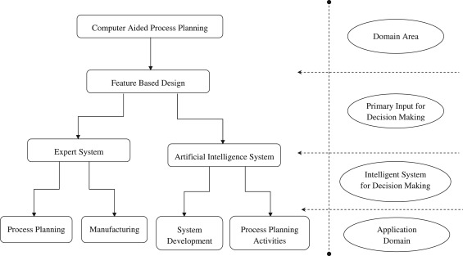

Fig 7: EXAMPLE FOR AI APPLICATION IN POWER SYSTEM (TRANSMISSION LINE)

**EXAMPLE FOR AI APPLICATION IN POWER SYSTEM (TRANSMISSION LINE) •**

Consider a practical transmission line. If any fault occurs in the transmission line, the fault detector detects the fault and feeds it to the fuzzy system. • Only three line currents are sufficient to implement this technique and the angular difference between fault and pre-fault current phasors are used as inputs to the fuzzy system. •The fuzzy system is used to obtain the crisp output of the fault type. Fuzzy systems can be generally used for fault diagnosis. •Artificial Neural Networks and Expert systems can be used to improve the performance of the line. • The environmental sensors sense the environmental and atmospheric conditions and give them as input to the expert systems. •The expert systems are computer programs written by knowledge engineers which provide the value of line parameters to be deployed as the output.

**APPLICATIONS OF AI (Contd..):**

1. Control of network like location, sizing and control of FACTS devices.
2. Electricity markets like strategies for bidding, analysis of electricity markets.
3. Automation of power system like restoration, management, fault diagnosis, network security.
4. Applications of distribution system like planning and operation of distribution system, demand side response and demand side management, operation and control of smart grids, network reconfiguration.
5. Applications of distributed generation like distributed generation planning, solar photovoltaic power plant control, wind turbine plant control and renewable energy resources.
6. Forecasting application like short term and long term load forecasting, electricity market forecasting, solar power forecasting, wind power forecasting.

**EXAMPLE FOR AI APPLICATION IN POWER SYSTEM (TRANSMISSION LINE)(Contd..) •**

The ANNs are trained to change the values of line parameters over the given ranges based on the environmental conditions •Training algorithm has to be given to ANN. •After training is over, neural network is tested and the performance of updated trained neural network is evaluated. • If performance is not upto the desired level, some variations can be done like varying number of hidden layers, varying number of neurons in each layer. •The processing speed is directly proportional to the number of neurons. •These networks take different neurons for different layers and different activation functions between input and hidden layer and hidden and output layer to obtain the desired output. • In this way the performance of the transmission line can be improved.

**CONCLUSION:**

The main feature of power system design and planning is reliability, which was conventionally evaluated using deterministic methods. Moreover, conventional techniques do not fulfill the probabilistic essence of power systems. This leads to increase in operating and maintenance costs. Plenty of research is performed to utilize the current interest AI for power system applications. A lot of research is yet to be performed to perceive full advantages of this upcoming technology for improving the efficiency of electricity market investment, distributed control and monitoring, efficient system analysis, particularly power systems which use renewable energy resources for operation.

This paper introduces the application of artificial intelligence in power system in recent years, including artificial neural network, expert system, fuzzy theory and so on. These applications can greatly improve the efficiency of the power system, reduce the input of human and material resources, and play an important role in power system security. In the future, the scale of power system will continue to expand, its complexity is also constantly improved and will bring some more difficult factors to deal with, in which some artificial intelligence currently have their own different advantages and disadvantages and limitations, lacking of a power system applied to the effective hybrid intelligent, namely seek a more suitable method for artificial intelligence processing problems in power system that combines the advantages of artificial intelligence. Believe in the future, with the deepening of research, artificial intelligence will become more and more mature, and easier to be operate, to better solve the problems in power systems.

**REFERENCES:**

[1] Zhao Gang. Artificial intelligence technology and its application in relay protection [J]. Jiangsu science and technology information, 2014 (24). J. Clerk Maxwell, A Treatise on Electricity and Magnetism, 3rd ed., vol. 2. Oxford: Clarendon, 1892, pp.68–73.

[2] Wang Lu, Mou Jiaqi, Hou Jianping,, et al. Research progress on electrode selection for hydrogen production from water electrolysis [J]. chemical industry development, 2009, 28 (S1):512-515.

[3] Tang Huajin, Chen Hanping. Research on the application of artificial intelligence technology in electric power system [J]. electric power construction, 2002, 23 (1):42-44.

[4] Power system relaying committee mark enns et al.Working group D10 of the line protection subcommittee.Potential applications of expert systems to power system protection.IEEE Trans on Power Dalivery,1994,9(2):720～ 728

[5] Lee S J.An expert system for protective relay setting of transmission systems.IEEE PWRD,1990,5(2):705～ 714Y. [6] Liu Lifeng, high school and Germany. Fuzzy knowledge processing of power system relay protection expert system. Automation of electric power systems, 1997,21 (6): 34 ~ 37 proposed the knowledge expression method and its reasoning model of relay protection fuzzy design.

[6] Patrick Henry Winston, Artificial Intelligence, Pearson. [

[7] George F. Luger, Artificial Intelligence : Structures and Strategies for Complex Problem Solving, Pearson.

[8] Stephen Lucci, Danny Kopec, Artificial Intelligence in the 21st Century, Mercury Learning & Information.

[9] David L. Poole, Alan K. Mackworth, Artificial Intelligence : Foundations of Computational Agents, Cambridge University Press.

[10] Mohamad Hassoun, Fundamentals of Artificial Neural Networks, A Bradford Book.

[11] Sandhya Samarasinghe, Neural Networks for Applied Sciences and Engineering, Auerbach Publications.

[12] Martin T Hagan, Howard B Demuth, Mark H Beale, Neural Network Design, Martin Hagan.

**INSTRUCTION FOR SEMINAR REPORT**

* All the pages should have boundary lines
* The Spiral binding cover of Seminar Report should be white transparent with white background.
* Line spacing is 1.5
* Letter size 12
* Heading 14 or 16
* Font is Times New Roman
* All Paragraph must be justified
* Seminar Report should contain minimum 30-35 pages
* Students have to submit three hard copy of seminar report on their day of Presentation
* Use Glossy papers for the first 3 pages (i.e. front page ,certificate page and acknowledgement page)
* References must be given in IEEE format